if((i+j+k)%2==0)

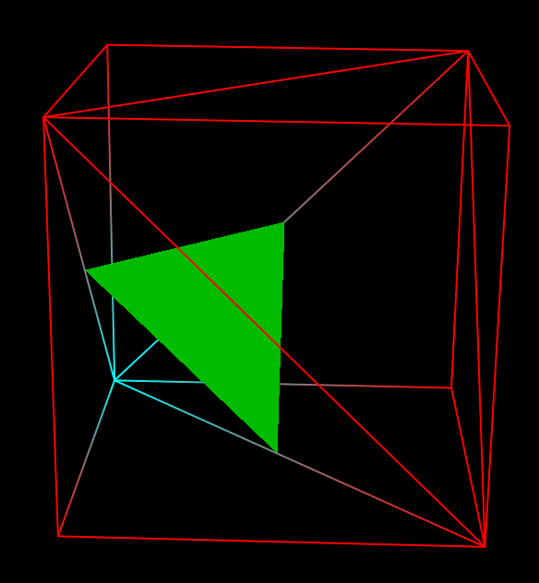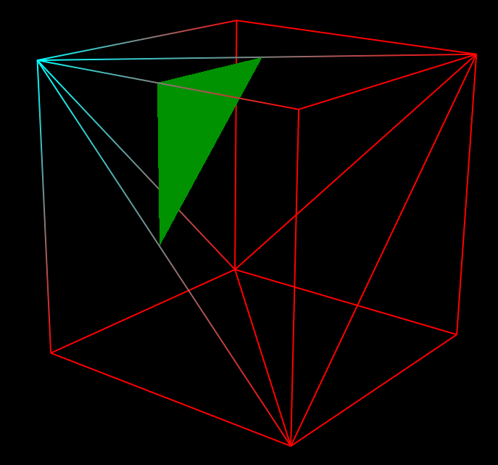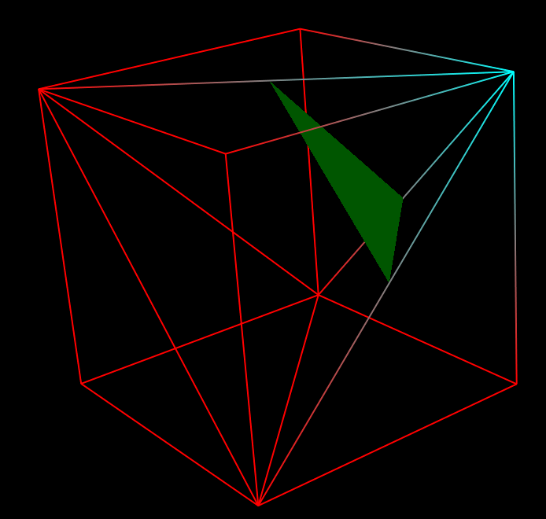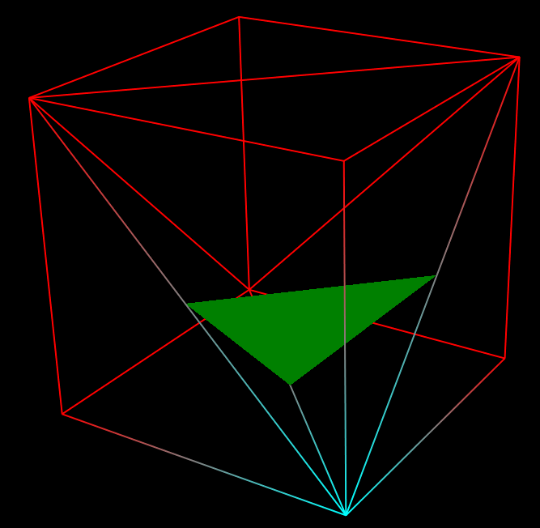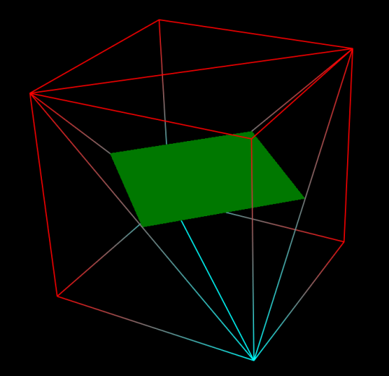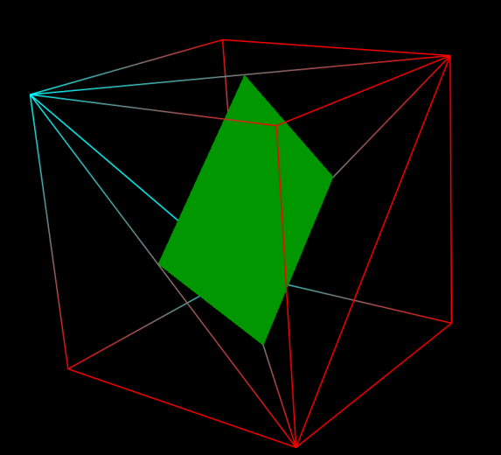

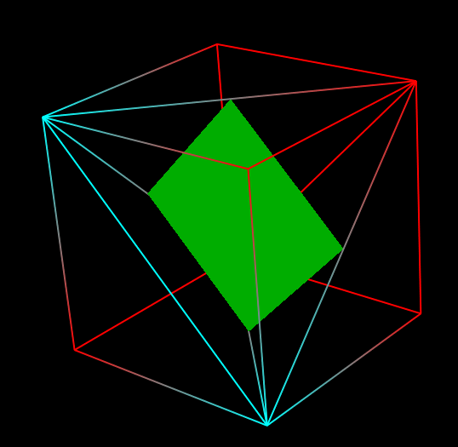

**if(leftCenterEdgeCoordinateIndices[k][i][j]!=-1&&frontCenterEdgeCoordinateIndices[k][i][j]!=-1&&upCenterEdgeCoordinateIndices[k][i][j]!=-1)c+=6;**

**elseif(frontCenterEdgeCoordinateIndices[k][i+1][j]!=-1&&upCenterEdgeCoordinateIndices[k+1][i][j]!=-1&&leftCenterEdgeCoordinateIndices[k][i][j]!=-**

**elseif(leftCenterEdgeCoordinateIndices[k][i][j+1]!=-1&&upCenterEdgeCoordinateIndices[k+1][i][j]!=-1&&frontCenterEdgeCoordinateIndices[k][i][j]!=-**

**elseif(frontCenterEdgeCoordinateIndices[k][i+1][j]!=-1&&leftCenterEdgeCoordinateIndices[k][i][j+1]!=-1&&upCenterEdgeCoordinateIndices[k][i][j]!=-**

**elseif(leftCenterEdgeCoordinateIndices[k][i][j]!=-1&&frontCenterEdgeCoordinateIndices[k][i][j]!=-1&&leftCenterEdgeCoordinateIndices[k][i][j+1]!=-1&&frontCenterEdgeCoordinateIndices[k][i+1][j]!=-1)c+=12;**

**elseif(frontCenterEdgeCoordinateIndices[k][i][j]!=-1&&upCenterEdgeCoordinateIndices[k][i][j]!=-1&&frontCenterEdgeCoordinateIndices[k][i+1][j]!=-1&&upCenterEdgeCoordinateIndices[k+1][i][j]!=-1)c+=12;**

**elseif(upCenterEdgeCoordinateIndices[k][i][j]!=-1&&leftCenterEdgeCoordinateIndices[k][i][j]!=-1&&upCenterEdgeCoordinateIndices[k+1][i][j]!=-1&&leftCenterEdgeCoordinateIndices[k][i][j+1]!=-1)c+=12;else b++;**